**ASSIGNMENT 7.1**

**Input(DATA SET):**

We have a dataset of sales of different TV sets across different locations. Records look like: Samsung|Optima|14|Madhya Pradesh|132401|14200

The fields are arranged like: Company Name | Product Name | Size in inches | State | Pin Code | Price Sales_TV: https://github.com/prateekATacadgild/DatasetsForCognizant/blob/master/sales_differentTV.txt

**Problem:**

* Write a Mapreduce program to modify Sales of different TV Task 2 (refer session 5 assignment 2) to use a custom partitioner with 4 reducers. Make sure that all records whose company name starts with A-F (upper or lower case) should go to 1st reducer, those starting with G-L to 2nd reducer, those starting with M-R to 3rd reducer and others to 4th reducer.
* Modify Sales of different TV Task 2 (refer session 5, assignment 2) to take advantage of Combiner.

**Problem:**

* Write a Mapreduce program to modify Sales of different TV Task 2 (refer session 5 assignment 2) to use a custom partitioner with 4 reducers. Make sure that all records whose company name starts with A-F (upper or lower case) should go to 1st reducer, those starting with G-L to 2nd reducer, those starting with M-R to 3rd reducer and others to 4th reducer.

**Program:**

**task1:**

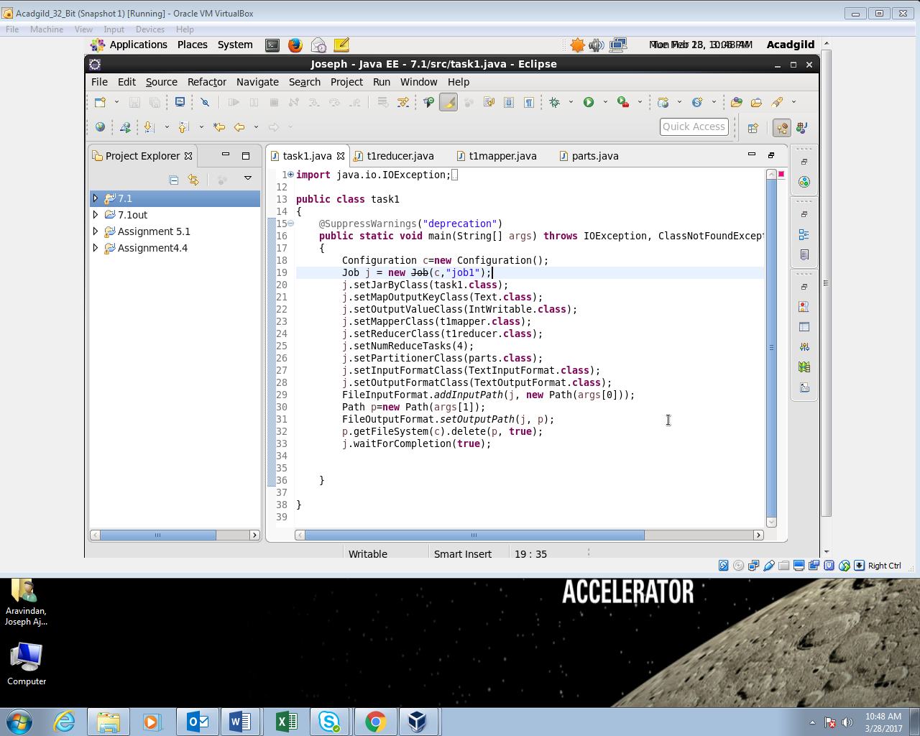

**T1reducer:**

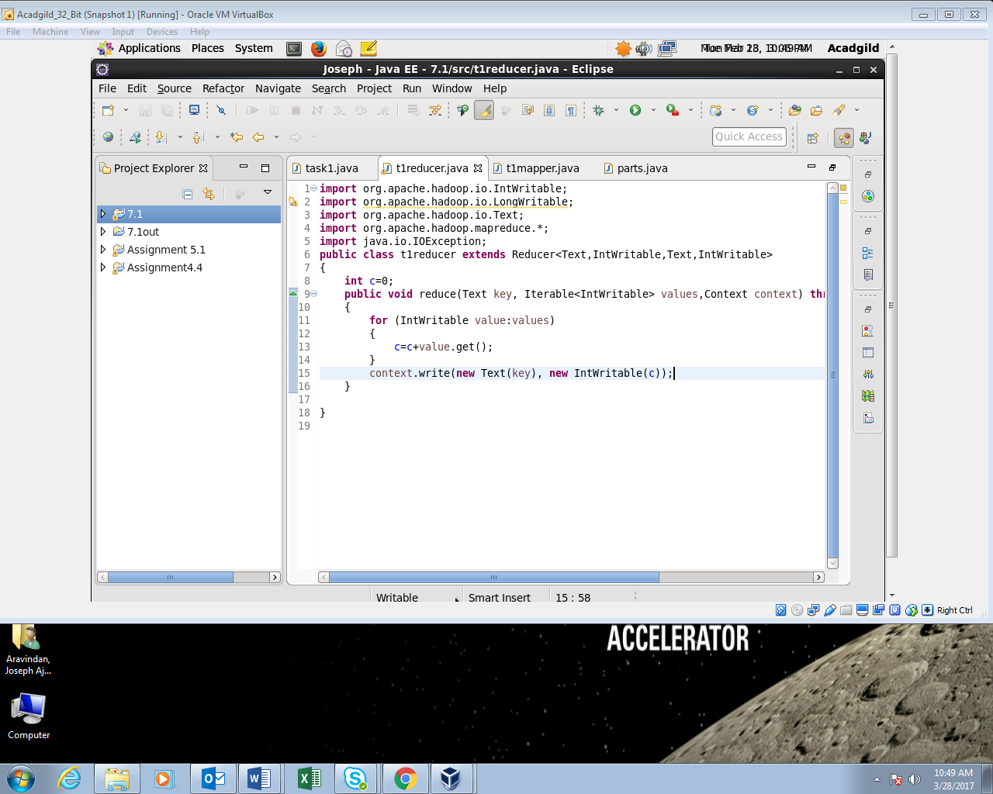

**T1mapper:**

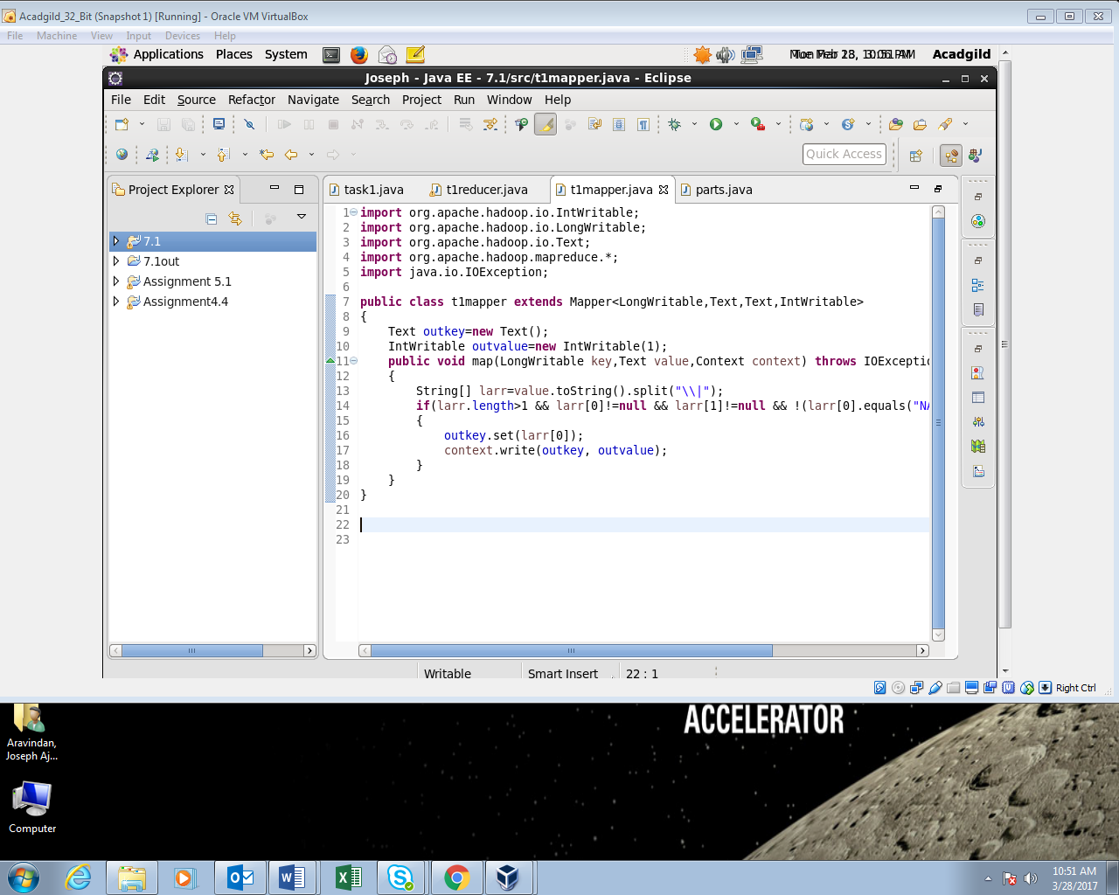

**Parts:**

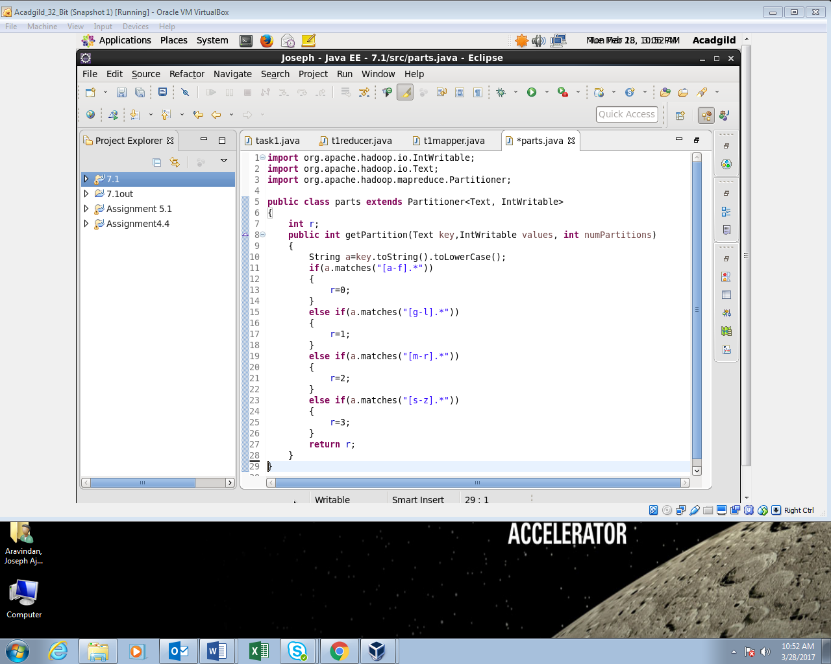

**Output:**

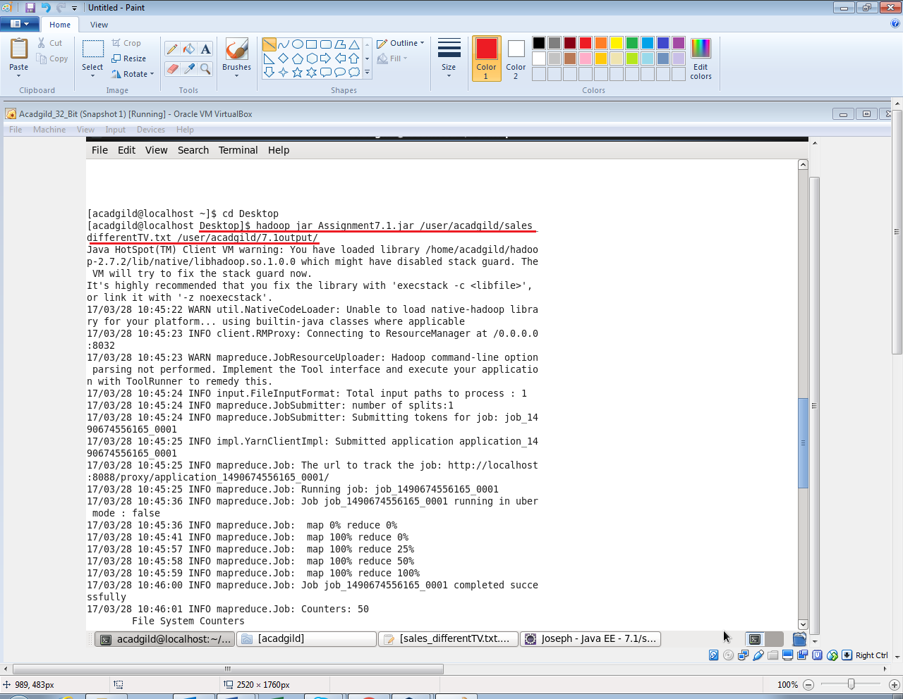

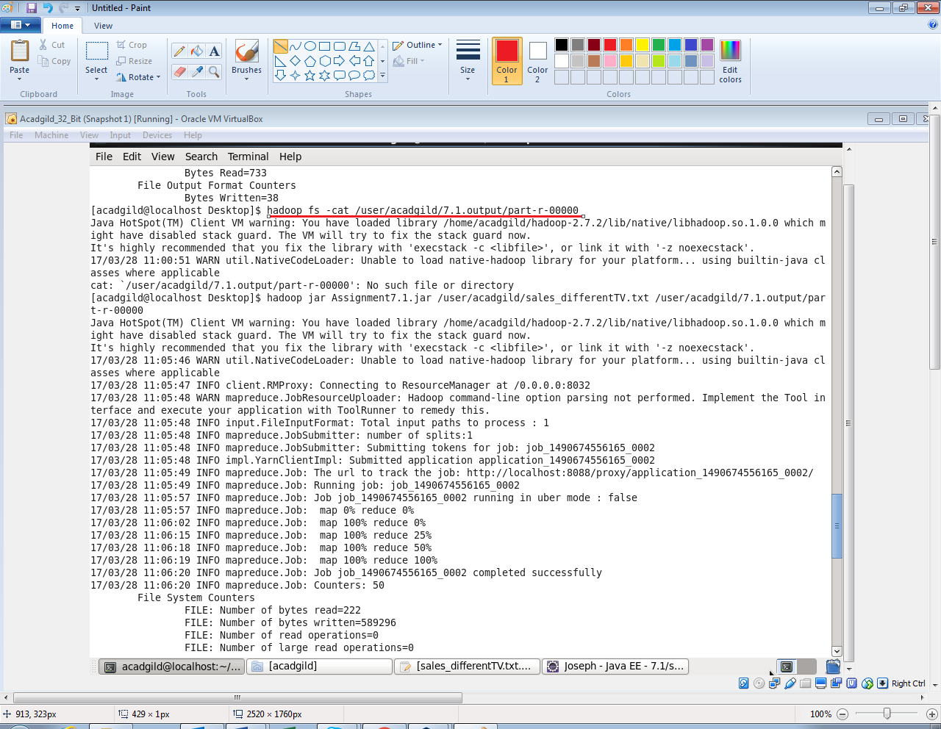

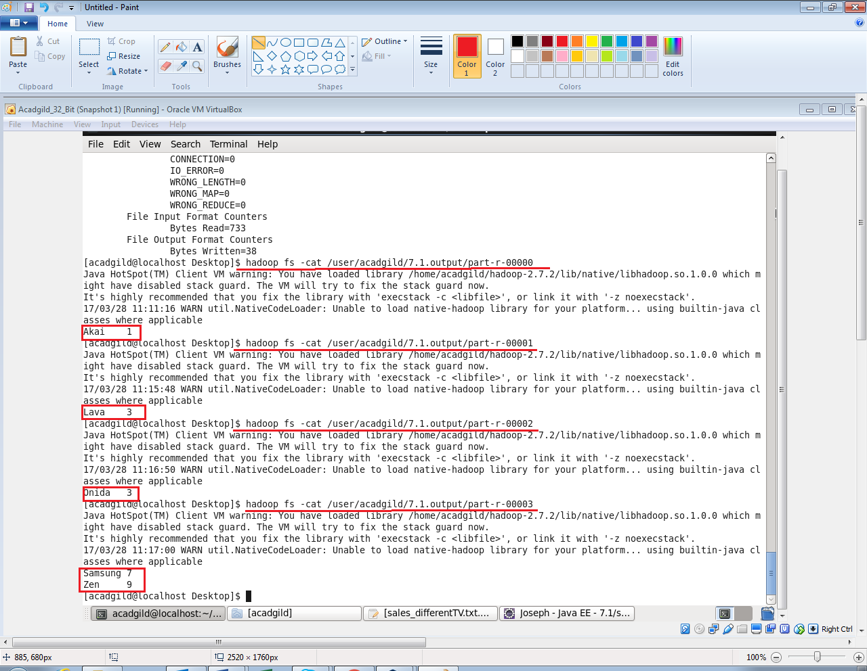

**Problem:**

* Modify Sales of different TV Task 2 (refer session 5, assignment 2) to take advantage of Combiner.

**Program:**

**Task1:**

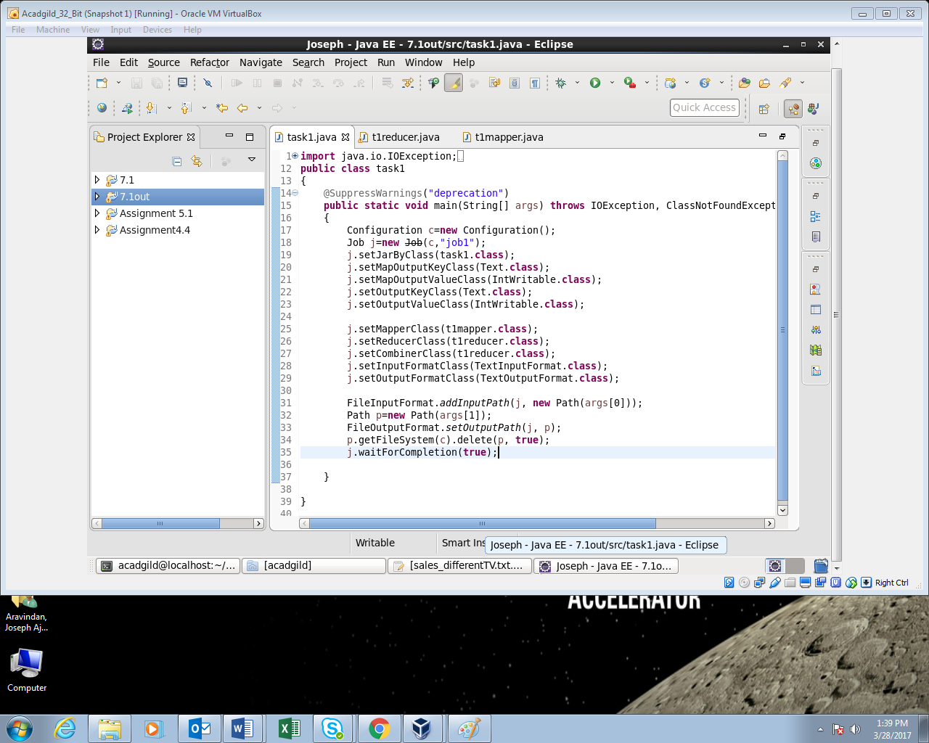

**T1reducer:**

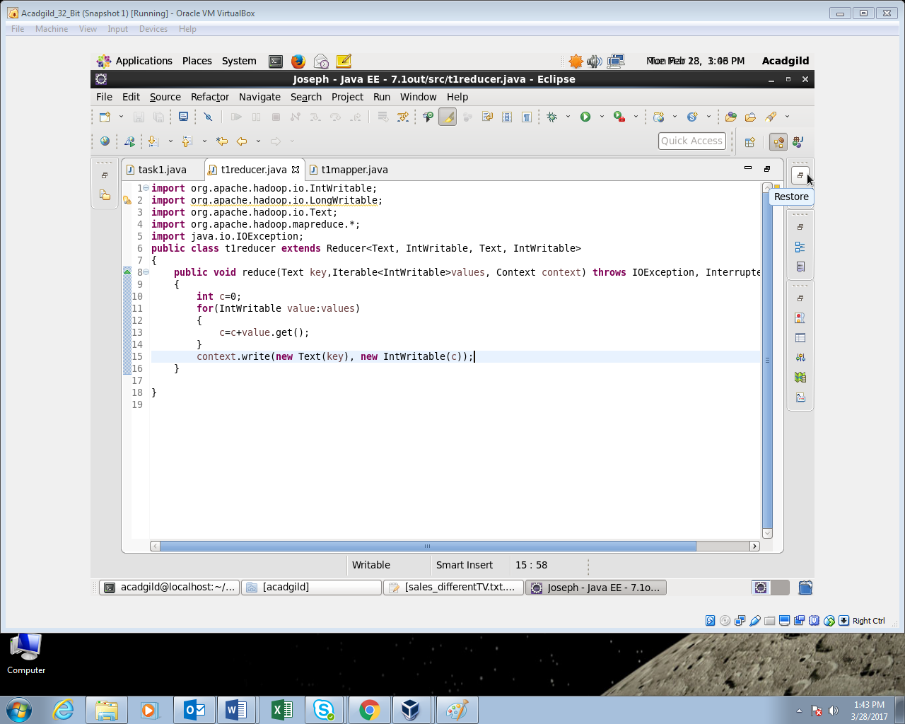

**T1 mapper:**

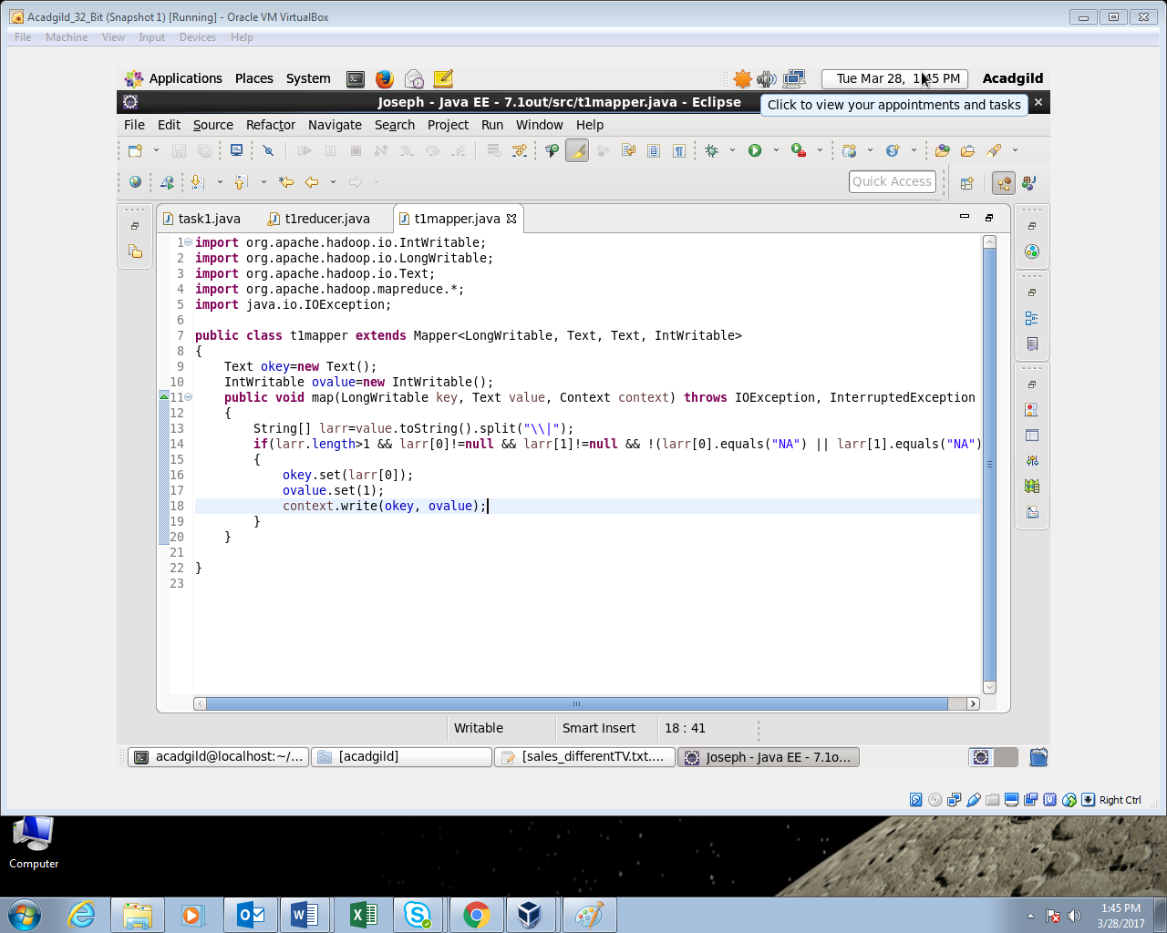

**Output:**

